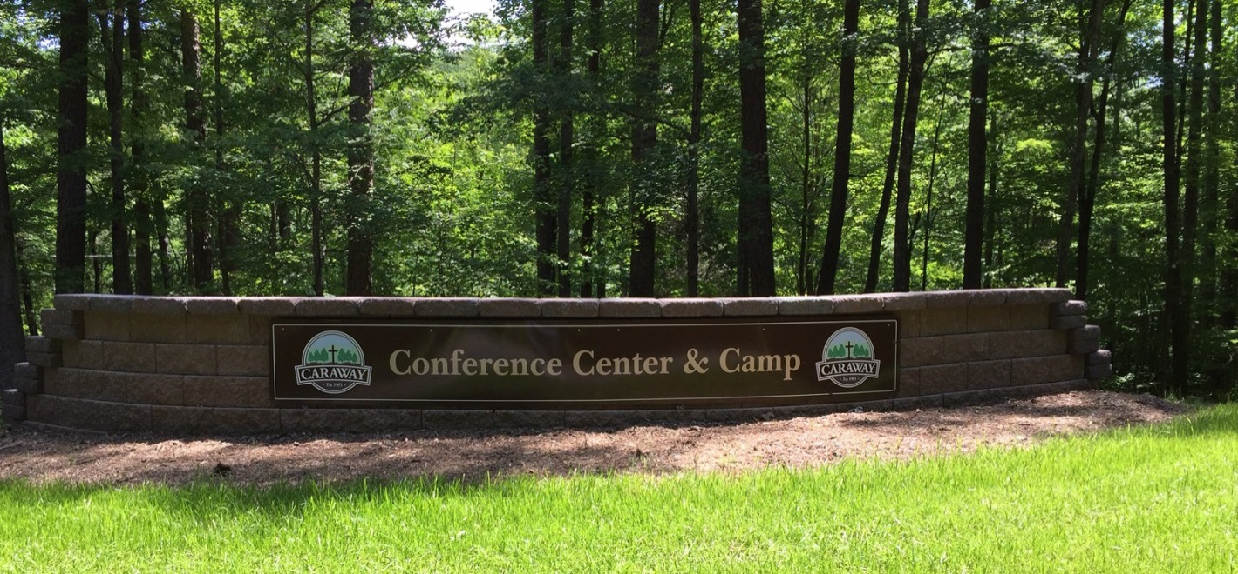
North Carolina Summer Camp
June 2017 Update
- REGISTRATION EXTENDED THROUGH JULY 9TH! -
Due to issues with the pay portal associated with the Camp Caraway Account, we are extending registration and final payment for the 2017 North Carolina Summer Camp through July 9th! We have been working with the Camp staff to address the problem. As of late June, the system appears to be back on-line and functioning correctly. If you have any trouble either registering and/or paying for the camp, please try registering/paying again. If you continue to encounter problems, please contact Ms. Andi Wilson at 336-629-2374 xt. 9210, between 9am and 2pm, EDT, Monday-Friday. We apologize for any inconvenience these issues may have caused and thank you for your understanding.

The 2017 North Carolina Summer Camp, will be held from July 16th – 22nd at Camp Caraway in central North Carolina, just south of Greensboro, NC.
Camp will begin with check-in from 3:00 – 5:00pm on Sunday, July 16th. Please do not plan on checking-in prior to 3:00pm as rooms will not be available until then. For those who do arrive earlier, we have planned a variety of fun activities, games and other events including a guided tour of the campgrounds in an open trailer, information stations, snacks and more. The evening meal will be from 5:30 – 6:30pm and the evening service will begin at 7:30pm. Camp will conclude on Saturday, July 22nd after lunch.
We encourage those who plan to attend to complete their registration as soon as possible. We need to have all registrations by July 9th. Payment in full will be due on or before that date. Registration will be on-line at the following address: caraway.org click the “Register for Your Event” button in the middle of the page. The web-site will walk you through the registration process. In addition, a detailed description of how to register is included as part of this announcement..
After you register online, you will receive an email with a link for a required form that will need to be submitted for each individual in your family that will be attending. On this form, there will be a place for you who will be registering as individuals (no other family members) to advise us of any person you wish to room with. We will make every effort to assign rooms based on these requests. The goal is to double occupy each room as much as possible. If you require single occupancy due to medical or other needs we will accommodate your request. We will attempt to honor all other requests for single occupancy; however, these requests will result in an additional charge of $22/night. This extra charge will be collected upon arrival the first day of camp.

Venue Highlights
Camp Caraway is located about 20 miles south of Greensboro, NC and presents a wonderful venue for our summer camp. Lodging will be in hotel type rooms with pillows, linens and towels provided. Meetings will be held in a new 300+ seat auditorium located adjacent to the residences. Meals will be prepared and served in a cafeteria located on the lower floor of the conference center. This is the same building where the overnight rooms are located. An elevator is available for your convenience. The 2017 camp will be held from July 16th-22nd. The camp GPS address is, 4756 Caraway Mountain Rd., Sophia, NC 27350
Numerous activities will be available to the attendees. More information regarding activities is presented in the next section.
Activity Information
While we are all aware that the primary purpose of our gathering is to meet with and worship the Lord and enjoy the fellowship of the Saints, there is no reason not to enjoy the numerous activities being offered by Camp Caraway. Below is a list of activities being offered to us. Some of the activities may not be available each day we are on-site:
- Archery - Water Trampoline - Basketball
- Bazooka Ball - Canoes - High Ropes Course
- Hiking - Kayak - Low Ropes Course
- Outdoor Gym - Stand-Up Paddle Board - Pedal Cars
- Outdoor Pool - Volleyball - Large water slide – lake
- Zip Lines - Lake – swimming - Softball

We are working with Camp Caraway to ensure that all activities are organized and handled in an orderly way.

Caraway will make 16 free passes available on a daily basis for visits to the North Carolina Zoo which is about 15 miles away, just below Asheboro, NC. The North Carolina Zoo is the worlds largest natural habitat zoo. More information regarding trips to the Zoo will be made available at a later time.

A separate e-mail will be sent asking those who will be attending the camp to pick the top 5 activities they would like to participate in while at camp. It is important that you provide us with this information so that the staff will be able to maximize your enjoyment of these wonderful opportunities.

Other activities include camp-fires and wagon trail rides.

Flight arrangements should be made to the Greensboro airport (GSO). Airlines serving GSO include Allegiant, American, Delta, Frontier and United. Please contact Keith Hurley (336.294.2607) or Dave Heath (336.816.3203) to arrange airport pick-up.
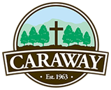
If you have any questions, please contact Keith Hurley at 336.294.2607.
May God Bless You,

Keith Hurley

